The Joel Lane Museum House

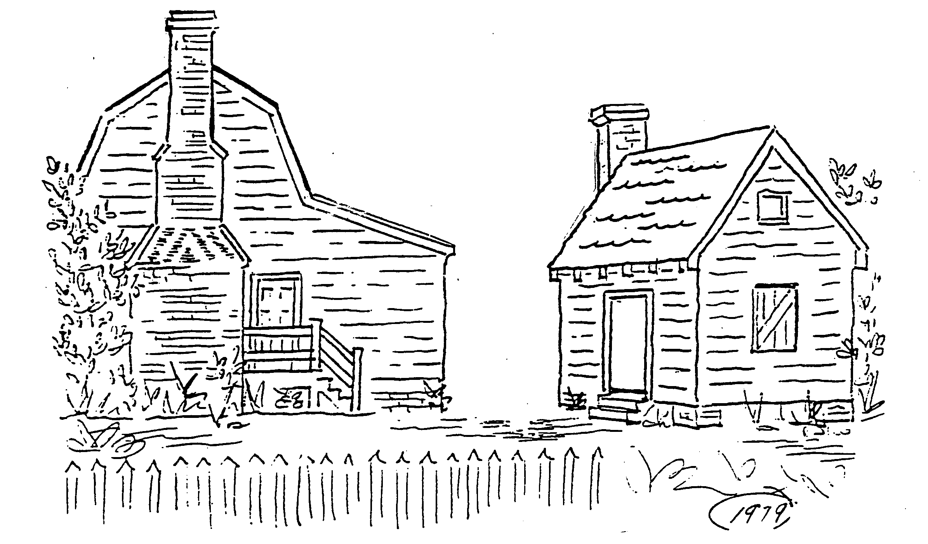

Listed in the National Register of Historic Places and a Raleigh Historic Site.
Owned and operated by the Wake County Committee of the National Society of Colonial Dames of America in North Carolina.

The Joel Lane Museum House staff is pleased that you have planned to visit our house museum and/or invited a staff member to visit your classroom. Preparation for the visit by using this packet will enhance students’ learning experience, and their knowledge of and appreciation for Joel Lane: a farmer, businessman, politician, patriot, soldier, delegate to the 1788 Constitutional Convention, and “father” of Raleigh and Wake County.

This packet contains background information, vocabulary, people, and concepts that we strongly suggest be presented to your students prior to their participation in the Joel Lane Museum House experience. Lesson plans have been included that should enhance learning and reinforce facts and concepts discovered at the Joel Lane Museum House.
The material in this packet may be copied (for classroom use only).

Welcome to the Joel Lane Museum House!

THE JOEL LANE MUSEUM HOUSE
TEACHER HANDBOOK FOR GRADES 3 and 4

TABLE OF CONTENTS

Logistics for the Joel Lane Museum House Experience 2

Background Information 3

Vocabulary 6

Lesson One: The House 13
Integrates Art, Information Skills, Language Arts, Mathematics, Technology
Inside and Out (Field Trip handout) 15
Measuring Tree Height (handout) 16

Lesson Two: The Herb Garden 17
Integrates: Art, Information Skills, Language Arts, Science, Technology
Herb Gardens in the era of Joel Lane (handout) 18
Some Uses of Herbs in Colonial America (handout) 19
Butter with herb Recipe (handout) 20

Lesson Three: Joel Lane in the American Revolution 21
Integrates: Art, Information Skills, Language Arts, Technology
Soldier’s Hardtack (handout) 22
N.C. American Revolutionary Sites Map (handout) 23
Crossword Puzzle (handout) 24

Lesson Four: Traveling in the Colonies 25
Integrates: Information Skills, Language Arts, Mathematics, Technology

Lesson Five: Colonial Culture 27
Integrates: Art, Health Education, Information Skills, Language Arts, Music, Physical Education
Virginia Reel (handout) 29
Period Clothing – Eighteenth Century (handout) 31

Resources: 36 Resources for each Lesson (pp. 36-38)
Resources for Students (pp. 38-39)

Logistics for the Joel Lane Museum House Experience

Pre-visit:
Copy and distribute the background information about Joel Lane, his family, farm, and historical significance of the Joel Lane Museum House. Please make sure your students understand the vocabulary words that they will hear frequently during the visit. A vocabulary list resource is provided that should assist you and your students in understanding the background information and the presentation during the visit. The words in bold print will be found in this resource.

Visit to the Site:
Please divide your class(es) into groups of approximately 12 -15 students. Enter the Joel Lane Museum House property through the large side gate on St. Mary’s Street. A docent will greet you outside the Visitors Center and give you and your students a synopsis of the history of Joel Lane and the house before the groups begin their tour of the house, kitchen building and garden. Plan on about 55 minutes for your tour.
Note:
Please remind your students that the Joel Lane House is a museum and that the objects in the house are antiques or valuable reproductions. Items are old, fragile, and may be one of a kind, and therefore are difficult or impossible to replace.
Remind your students to listen politely and carefully to the docent conducting the tour. The tour will proceed more smoothly and the docent will be less inclined to forget to mention important details if students refrain from asking questions until the docent requests them. Time will be provided for questions at various intervals during the tour.
If you have any questions prior to your visit, please call the curator of the Joel Lane Museum House at: 919 833-3431

Staff Visit to School:
Please advise the office that a Joel Lane Museum House representative is coming to visit your class.
Each class visited should have the following available for the presentation:
- table at the front of the room
(on which to display artifacts brought for presentation by the Joel Lane
Museum House representative)
- slide projector
- If more than one class is scheduled for the presentation, please provide a list with the teacher’s name, classroom number, and the amount of time you wish each presentation to last. (The Joel Lane Museum House classroom presentations can vary from 30 to 45 minutes in length.)
- A teacher must be present during presentations by visiting docents.

Resources:
Student and teacher resources are listed at the back of this packet.
See our web site for additional information not included in this packet.

Background Information
Born in 1739 near Halifax, North Carolina, Joel Lane was a farmer, businessman, politician, patriot, soldier, delegate to the 1788 Constitutional Convention, and founding father of Raleigh and Wake County. Joel Lane and his wife, Martha, had three children: Henry, James, and William. When Martha died, Joel Lane married her sister, Mary. Mary and Joel Lane had nine more children. In the area that was to become Raleigh, he purchased land on which he built his house. Eventually he owned 5,000 acres that he farmed with the help of 30 or more slaves.
The large amount of land Joel Lane owned provided everything needed for survival on Joel Lane’s plantation. Joel Lane’s plantation had a large garden, orchards, and crops of cotton, corn, oats, wheat, rye, and flax. There were cows, sheep, hogs, turkeys, geese, chickens, and other farm animals to help feed the people who lived and worked on the plantation. Mules and oxen were used to help with the work, and horses were used for transportation. There were even three beehives. Relatively few people lived in North Carolina in the eighteenth century. In order to have the labor required to run such a large, self-sufficient plantation, slaves were purchased in order to keep up with the work.
In the eighteenth century work was divided by a person’s class, gender, and age. Work assigned to slaves was different than work of the mistress or master of the plantation. Slaves worked as field hands, house servants, cooks, and in trades such as carpentry. The men in the Lane family would have organized the work on the plantation, and made decisions about harvesting. They may have had to do physical labor sometimes. The Lane women would have been responsible for running the household. They had to be sure everyone was fed and healthy. They would have made sure jobs such as cooking, cleaning, spinning, weaving, sewing, and the keeping of the kitchen herb garden were done properly. The children were also expected to do their share of work. They helped in the kitchen garden, ran errands, helped with the animals, gathered berries, combed wool, and did other tasks that were required. Joel Lane’s children were children of wealthy parents, however, and may not have had to work as hard as the children of farmers who were not as prosperous.
Joel Lane was active in the affairs of North Carolina both as a colony and as a state. He was a Johnston County representative to the Colonial Assembly held in New Bern. He introduced a bill in the Colonial Assembly to create Wake County. At the time Wake County was created, Governor Tryon was royal governor. The name of the county comes from Governor Tryon’s wife, Margaret Wake Tryon. Land around Joel Lane’s home became the Wake County seat (the place from which Wake County government operated). Because the building housing the new county seat was not yet completed, the first session of Wake County court was held at Joel Lane’s home.
Joel Lane was a loyalist, but his feelings about being loyal to the king changed. He became a patriot. As a patriot, he was one of many people from all walks of life in the colonies who participated in the formation of the United States. Joel Lane was elected as a delegate to the revolutionary Provincial Congress. After the Battle of Moore’s Creek Bridge during the Revolutionary War, Joel Lane distributed salt that was confiscated from loyalists to other patriots.
The Lane plantation and the area around it was the location of much activity. For example, the militia gathered at Wake Court House, near the Lane farm, during the Revolution. Many meetings of significance to the colony and later to the new state of North Carolina were held on his plantation. The General Assembly chose the Lane family farm for the some of their sessions. Both Joel Lane and his son, Henry, were delegates to the 1789 Constitutional Convention at Fayetteville that did ratify the U.S. Constitution after the Bill of Rights had been added. In 1792, Joel Lane sold the state of North Carolina 1,000 acres of land for the city of Raleigh.
Joel Lane’s house was saved because he was an important and influential figure in the history of our state. It was considered, in its early years, to be one of the finest houses in the area. At the time the house was built, no towns or villages were nearby. Roads were little more than primitive paths cut through forests and other rough terrain. Wild animals roamed. Native Americans may have inhabited land nearby. Building a house in colonial times was difficult. Land had to be cleared, trees cut for lumber and shingles, glass blown for the windows, and iron work made for the locks and hinges. What could not be made on site had to be brought to America from Europe. Imported goods were very expensive.
Joel Lane’s house was built when North Carolina was still one of the thirteen colonies belonging to England. Later, the city of Raleigh grew up around the building. Over the years, many people have owned the house. In 1927, the North Carolina Chapter of the National Society of the Colonial Dames of America, a historical organization dedicated to preserving colonial heritage, purchased the building after it was moved one block to its present location. Today, the house stands restored to its 1790 appearance. Much of the original structure remains intact.
Downstairs there are four rooms separated by a hall with a door at the front and back to allow for ventilation. The two front rooms each have a fireplace. The back room that is open to museum visitors may have been a guest bedroom. Upstairs there are two rooms, and they also have fireplaces directly above the ones downstairs.
We know what furnishings were in the house when Joel Lane died because the Wake County Courthouse has copies of his estate records on file. From these documents, we know that the antiques that have been placed in the house match closely those that Joel Lane might have had in his home.
The building behind the house is now called the kitchen. It is actually a middle class house built in the late 1700s. We are using this house to represent a colonial kitchen because the original was destroyed. It is believed that kitchens of the period were similar in appearance to the small house. A side door to the dining room of the main house allowed food to be served directly to the table from the kitchen without walking through the main part of the house.
There were other buildings on Joel Lane’s plantation besides the ones on the property now. Many of these would have been agricultural outbuildings. Documents from the time tell us another of the buildings was an inn that Joel Lane built because there were no hotels. Even after the inn was built, he had many guests who stayed in his home because he was a man of influence in his community.
The garden directly behind the house and kitchen was designed in the style of a formal English garden. On the side of the house is the herb garden with herbs and flowers typical of the kind that might have been part of Joel Lane’s own herb garden. Keep in mind that a plantation was really a very large farm. In Joel Lane’s day, the area behind his house could have been a farmyard with cats, dogs, chickens and ducks roaming about. There would have been a kitchen garden growing vegetables. Instead of a few apple trees, an apple orchard would have stood away from the house. The garden at Joel Lane Museum House is meant to show examples of the different types of gardening that was done in the eighteenth century.
The house underwent a major restoration in the early 1970s. At the same time, archaeologists excavated part of the original house site on Boylan Avenue. Remains, believed to be that of Joel Lane and some of his family, were discovered at the original property, along with metal buckles, buttons, pottery, and other artifacts of the colonial period. The remains were re-buried in City Cemetery on New Bern Avenue.
What we know of Joel Lane’s life, and what is left of the plantation he built, helps us understand the beginnings of North Carolina and this nation. We are fortunate to have the home of the “Father of Raleigh” and the “Father of Wake County” preserved for us to enjoy and learn from today.

VOCABULARY

(The vocabulary list is a resource that may be used as a supplement to the background information provided. )

Antiques: very old and valuable objects, generally over one hundred years old

American Revolution: the war fought by American colonists to gain independence from England.
The colonists were angry at the way England ruled them and taxed them. North Carolinians fought the war with weapons and with words. North Carolina was the first colony to vote for independence from England.

Archaeologist: scientist who works like a detective to look for clues to learn how people lived in the past. Archaeologists gather evidence about the past from things such as seeds, bones, soil, house floors, pottery, etc.
Archaeologists gather artifacts and other information from a dig site and then work in their laboratories to try to understand their discoveries. After studying and analyzing their findings, they write reports so that other people can learn from their work. (See also: Artifacts)

Artifacts: tools or other items made or used by people that can be moved or carried which archaeologists look for at a dig.

Every artifact is like a piece of a puzzle archaeologists use to try to understand people and cultures of the past. Buttons, buckles, pottery and other items believed to belong to Joel Lane have been found at a dig on the property he once owned. Archaeologists believe that they probably belong to Joel Lane or one of his family members because of the way they are made and where they were found. (See also: Archaeologists)

Battle of Moore’s Creek Bridge: battle fought in 1776 in North Carolina during the Revolutionary War in which North Carolina Continentals (soldiers of the American army during the revolutionary period) and militia defeated loyalist troops seeking to join the British army and end the rebellion.
The Battle of Moore’s Creek Bridge and another battle near Charleston, South Carolina postponed a British invasion of the southern colonies for two years. After the battle of Moore’s Creek Bridge, Joel Lane distributed salt confiscated from loyalists to patriots. (See also: militia, American Revolution, Revolution, Revolutionary War, Loyalist, Patriot)

Bill of Rights: the first 10 amendments added to the Constitution of the United States of America.
The Constitution granted the federal government more power than an earlier document that set the law of the land. Some delegates to the Constitutional Convention were worried that the federal government, using the new more powerful document, would intrude on individual rights. Joel Lane was one of the delegates that refused to sign the first draft of the Constitution without a bill of rights. The first 10 amendments to the Constitution protect such individual rights as freedom of speech, protection against unlawful search and seizure, and the right to a trial by jury. (See also: Constitution, Constitutional Convention)

Capital: a city or town that is the official seat of government of a state or nation.
There have been several capitol buildings. The first capitol building in Raleigh was destroyed by fire in 1831. The second capitol building was made of stone brought by horse-drawn cars on a railroad track from a quarry just outside the Raleigh. The present capitol building, completed in 1840, is an excellent example of Greek Revival architecture.
capital and capitol: notice the difference in the spelling of these words:
capitAL - from old words meaning head or top or of most importance
capitOL - from old words used for buildings or places where there are buildings
The Capitol Building is in our nation’s capital, Washington, DC.
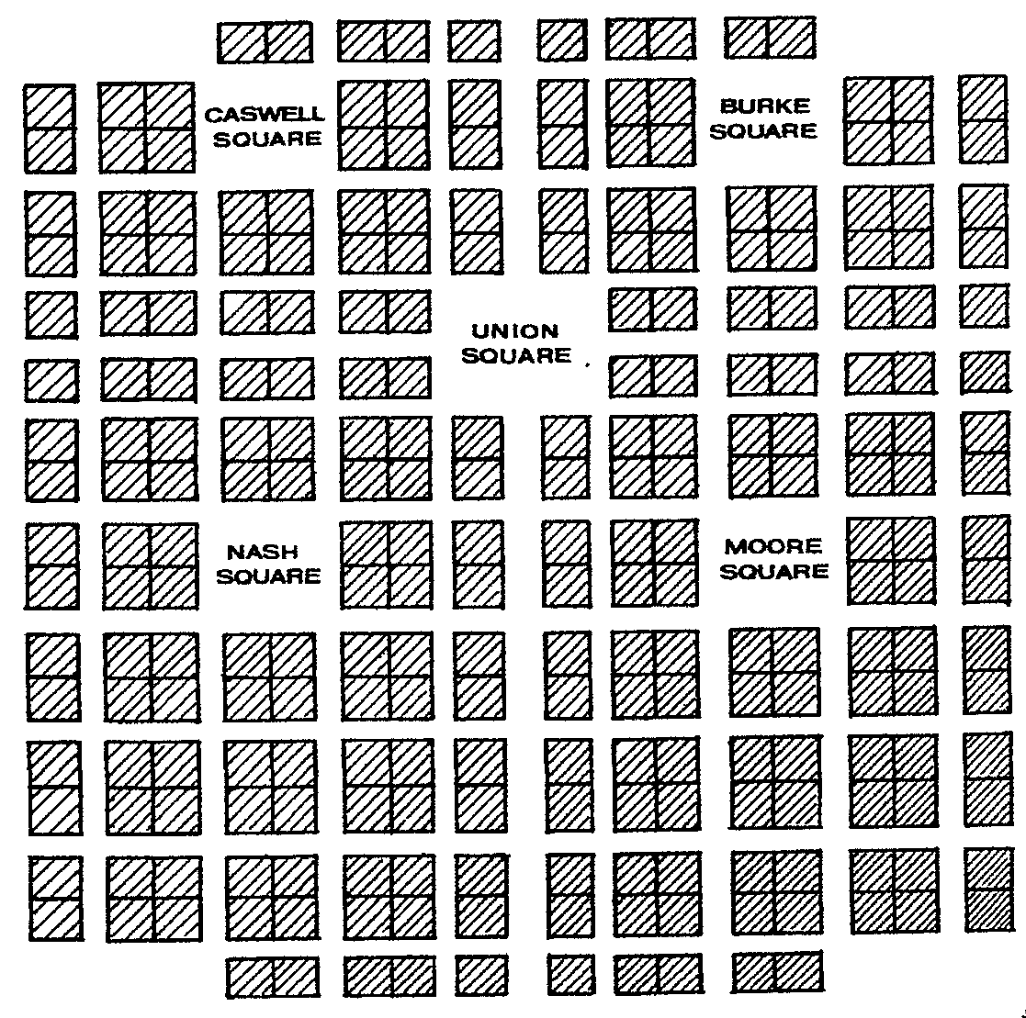
City of Raleigh: the capital of North
Carolina. Joel Lane sold the state of
North Carolina the 1,000 acres of land
on which to locate its capital.
In 1792, six state commissioners were appointed to decide on a site for the new capital city. They stayed on Joel Lane’s plantation. After traveling on horseback and visiting many sites, the commissioners met in the Lane family dining room and chose 1,000 acres of Joel Lane’s land for the new state capital. Joel Lane signed the deed over to the state on April 5, 1792. The General Assembly voted to name the new capital Raleigh after the Englishman who encouraged British colonization of America, Sir Walter
Raleigh. This is the land plan as it was drawn by William Christmas in 1792. Each large box contains 4 one-acre lots.

Class: a group of people considered as a unit according to economic, occupational, or social status; especially in this case, a social rank: as, the working class, the upper class, the middle class.
Joel Lane and his family would have been considered upper class people in the time in which they lived because they owned a great deal of land and property. Their home reflected their economic (wealthy), occupational (planter), and social (community leader) status.

Colony: a territory distant from the place having political control over it.
North Carolina was one of the thirteen British colonies controlled by the King of Great Britain, George III, during the time before and during the American Revolution. (Great Britain is the name given to England, Scotland and Wales. George III also ruled over Ireland.) Colonialism is the political system in which a country has foreign colonies for economic gain. (See also American Revolution)

Colonial Assembly: governing body of a colony during the time America belonged
to England.
Joel Lane served as a representative to the Colonial Assembly from both Johnston and Wake Counties. He was a senator in the General Assembly after the Revolutionary War. Colonial Assemblies were renamed General Assemblies after the Revolutionary War because the colonies re-formed as states.

Constitution: written document which explains how American government works.
It was signed by fifty-five delegates in Philadelphia in 1787, the Constitution of the United States was sent to Congress and made the law of the land the following year. The Constitution has seven articles that set up the legislative, executive, and judicial branches of government and describe their powers. In addition, the articles tell the states and the federal government about their roles toward each other. The first 10 amendments (changes or additions) of the Constitution are called the Bill of Rights. (As did others in the N.C. delegation, Joel Lane voted not to ratify the Constitution on the first vote because it did not contain a bill of rights. After the Bill of Rights was added, the North Carolina delegates voted to ratify the Constitution.) Additional amendments have been added over the years since the Constitution was ratified so that in the year 2000 there are 26 amendments to the Constitution. (See also: Bill of Rights, Constitutional Convention, Delegate)

Constitutional Convention: meeting held in Philadelphia in 1787 to write the Constitution.
There were several drafts of the Constitution which was written to take the place of a weaker document that was the law of the land. The final document went to all the states for ratification (approval). Then each state held its own constitutional conventions. N.C. ratified the U.S. Constitution on November 21, 1789 in Fayetteville. (See also: Bill of Rights, Constitution, Constitutional Convention, Delegate)

Cotton: a plant containing seeds, surrounded by downy white fibers that can be spun into thread.
Cotton seeds would have been sown by field hands (often slaves) and hand picked when the cotton was ripe. The seeds are very difficult to remove and in colonial times seed removal would have been done by hand. Joel Lane may have grown some cotton for use on his own plantation but probably would not have grown it for sale. The soil in the Piedmont area is not the best for growing cotton. Eli Whitney did not invent the cotton gin that removed seeds from the cotton boll until 1793.

Delegate: person authorized to act for others, a representative.
Joel Lane was a North Carolina delegate to the state’s 1788 and 1789 Constitutional Conventions. At the 1789 convention in Fayetteville the Constitution of the United States of America was ratified. Congress then appointed a committee to schedule the first elections for the new government of the U.S. and set the date when the new government would begin operation. (See also: Constitution, Constitutional Convention, Bill of Rights)

Democracy: government run by the people, either directly or through elected representatives.
To be a democracy, the people accept and practice equality of rights, opportunity, and treatment.

Eighteenth Century: the years from 1701 – 1800.
Think about the first century: you will understand that it includes the years 1 – 100. The year 101 is the beginning of the second century. The second century ends in the year 200. The year 201 begins the third century. Another way to think about it: when babies are born until the time of their first birthday it is their first year of life, after they turn one year old, they are living in their second year of life. That is similar to the way centuries are counted.

Gender: male or female

Henry Lane: Joel Lane and his first wife Martha’s oldest son.
Henry married his first cousin, Mary Hinton. When Henry and Mary Hinton married, Joel Lane gave him 2,000 acres of land and 16 slaves to set up household. Henry and his wife had a daughter, Peggy, who married Moses Mordecai, a young attorney. They moved into her father’s house, which later took the name Mordecai (pronounced Mor-de-key) House.
Note: The Mordecai House is part of the Mordecai Historic Park in Raleigh.

Herb Garden: garden containing plants used for medicines, food flavoring and other household uses
Planted beside the Joel Lane house, the garden contains typical herbs planted by farmers during the 18th century. The herb garden during Joel Lane’s lifetime would have been planted near the kitchen so that the plants could be used as needed. Herbs were necessary for food flavoring, medicines, dyes for wool and flax, and strewing (the use of herbs and plants for deodorants and pesticides) in the 18th century. Herbs could be used fresh or dried and became ingredients in a variety of teas, potpourris, and medicines. Colonial housewives had how-to books called “herbals” to instruct them in the ways the herbs could be used. The colonists harvested, saved, and traded their seeds. The garden at Joel Lane’s Museum House contains plants such as tansy, horehound, kerria, foxglove, germander, yarrow, tarragon, parsley, rhubarb, peppermint, orangemint, baytree, chamomile, basil, coral honeysuckle, chives, rosemary, lavender, catnip, thyme, sage, borage, and lamb’s ear. There is a sundial in the center of the garden.

Joel Lane: Joel Lane was a patriot and politician who is known as the Father of Raleigh and the Father of Wake County.
He was an important person during his lifetime and held many important jobs in government: Wake County Court Justice, Lt. Colonel in the Wake militia, member of the N.C. Provincial Congress at Hillsborough, Senator from Wake County to the N.C. General Assembly for 13 terms, served on the N.C. Committee of Safety, member of the 1788 and 1789 Constitutional Conventions.

Kitchen: place for preparation and cooking of food.
This kitchen is an authentic 18th century dwelling and is probably very similar to the kitchen belonging to Joel Lane. All the food was cooked in the kitchen building and brought to the main house. Cooking was done in a separate building so that out-of-control cooking fires would not destroy the main house. It was also a way to keep cooking odors and the heat of the cooking fires away from the main house in the summer. A separate kitchen was very common in the upper class South during this period. The cook might have slept on a cot in the kitchen or she and her family, who were slaves, might have lived upstairs.

Loyalist: colonists who believed in the British cause during the Revolutionary War
Most loyalists were from the upper class, such as landowners, clergy, and officeholders who worked for the crown. Joel Lane was a loyalist for a time like most of his class, but became a patriot and served the Revolutionary cause. We can guess one reason his allegiance changed was economic. Colonists felt they were being taxed unfairly. Loyalists were also called friends of the government, the king’s friends, Tories, or royalists.

Middle Class House: often only one room, sometimes with a loft for sleeping.
A middle class house would not be as grand as the Joel Lane House. The middle class in the colonial period would have owned property, though not as much as Joel Lane, and might have been merchants or craftsmen. The house now used by the Joel Lane Museum House as the kitchen was originally a middle class house built around the same time that Joel Lane’s house was built. A middle class house was very rough in comparison to Joel Lane’s house.

Militia: an army composed of volunteer citizens rather than professional soldiers, called out in times of emergency.

New Bern: capital city of North Carolina before Raleigh, located in eastern North Carolina on the Pamlico Sound.
Joel Lane was elected as a Johnston County representative to the Colonial Assembly held in New Bern in 1770. New Bern was the capital of North Carolina when it was still a British colony. Governor Tryon built Tryon Palace there for use as a government building. After independence from Britain, it was decided that the state capital should be moved inland to the central part of the state so that it would less vulnerable to attack from the sea and so people in the western portion of the state could get to the capital more easily. Commissioners met in 1792 in Joel Lane’s dining room to decide on the location of the new capital. Joel Lane sold the state 1,000 acres of his land for the new capital. (See also: Capital, City of Raleigh)

Original: first; earliest, not a copy
Much of the Joel Lane Museum House is made of materials from the time it was built by Joel Lane. The house was preserved because early 20th century citizens recognized that Joel Lane was a very important person in the history of North Carolina and the founding of the United States and raised the money to save the dwelling.

Outbuildings: all buildings other than a main house are known as outbuildings.
Besides Joel Lane’s house, the kitchen, and houses for the slaves, there were other buildings on the plantation. Perhaps a building where carding and spinning of the wool might be done was there, perhaps there were buildings for the various craftsmen who lived and worked on the property. Barns and chicken coops would certainly have been part of the landscape, as would storage buildings.

Patriot: during colonial times, person who believed that the colonies should be independent from England. Patriots were also called Whigs, Liberty Boys, Rebels, Colonials, or Sons and Daughters of Liberty.
People who were patriots like Joel Lane believed that America should have independence from Great Britain; that is, they believed America should be a country free from the control of the king of England.

Plantation: in colonial times, a large, self-sufficient farm with at least 20 slaves.
At the time of his death, Joel Lane owned over 5,000 acres of land and 32 slaves. Joel Lane’s plantation had a large garden for vegetables, an herb garden, corn, oats, wheat, rye, flax, perhaps a field of cotton for home use, farm animals, horses for transportation, and beehives. The Lane men organized the work and managed production. What was not needed for the plantation’s survival was sold, some to people in other states or to people in Europe. Selling what was grown on the plantation (called cash crops) allowed owners of well run plantations to become wealthier. (See also: Slaves, Cotton, Herb Garden)

Pottery: pots, bowls, dishes, etc., made of clay and hardened by heat.
Pottery shards are fragments or broken pieces items such as dishes and some were found by archaeologists near where Joel Lane built his house.

Provincial Congress: formal assembly of delegates, elected locally in the N.C. colony’s counties and towns, which met to discuss complaints against the royal governor and the king. The Provincial Congress oversaw all actions of the county government including the sections that made laws, held court, and called up the militia.
Joel Lane served in the Provincial Congress, the Council of Safety, and the county Committee of Safety. At times, Joel Lane was serving in all three bodies at the same time. The Provincial Congress and those who served in it were very powerful people.

Ratify: approve or confirm; to give formal sanction (authorization, permission)

Remains: what is left of the dead body.

Archaeologists believe that the remains found at the original location of the Joel Lane House are of Joel Lane and some of the members of his family. The remains were reburied in Raleigh’s City Cemetery.

Reproductions: a copy or duplication, or close imitation.
The desk and chair in the parlor belonged to Joel Lane and some of the other pieces in the house to members of his family or their descendents. Other pieces of furniture are antiques from the period or reproductions.

Revolution: overthrow of a government or form of government with another taking its place.
Many countries have had revolutions. The revolution that changed our system of government from a monarchy belonging to England to a democracy was the American Revolution.

Revolutionary War: the war (1775-1783) in which the American colonies won their independence from England.
(See also: Battle of Moore’s Creek Bridge, Revolution)

Royal Governor: governor put in charge of each of the colonies by the king.
The royal governor acted in place of the king. Some of the governors only wanted the job in order to make themselves rich. Colonists’ conflict with a royal governor was considered to be treason by the king. Governor Tryon was a royal governor of North Carolina prior to the Revolutionary War. (See also: Wake County)

Salt: white, crystalline substance found in natural beds, in seawater, etc., and used in seasoning and preserving food.
Salt was very expensive in colonial times. Joel Lane distributed to patriots the salt that had been confiscated from loyalists after the Battle of Moore’s Creek Bridge in North Carolina during the Revolutionary War. (See also: Battle of Moore’s Creek Bridge)

Self-Sufficient: to be able to get along without help, independent.

A plantation was a self-sufficient large farm with over 20 slaves that produced all that the owners and workers would need to survive. (see also: Cotton, Herb Garden, Plantation, Slaves)

Slaves: human beings with no personal rights or freedom who are owned by other human beings.
Children born of slave parents also became slaves. Slaves were purchased and used as labor on large plantations because there were relatively few people living in the colonies, and laborers were necessary to keep up with the work. Some slaves worked to keep the household by cooking, cleaning, laundering, and so on. Others did carpentry, were field hands, blacksmiths, or were trained in other trades necessary for the operation of the plantation. Slaves were used for most manual labor and to accomplish tasks their owners were unable and/or unwilling to do. Slave ownership increased after the invention of the cotton gin and before the Civil War. Most people in North Carolina did not own slaves. Most farmers in North Carolina who did have slaves owned less than 20. (See also: Kitchen, Plantation, Self-Sufficient)

Wake County: the county in which Raleigh is located.
Wake County was formed in 1771 from Johnston, Cumberland and Orange counties because the population of the area had increased and people did not want to travel to Smithfield for court proceedings. They also wanted their own representation in the assembly. Joel Lane was part of a committee that drew the boundaries for Wake County. It was named in honor of Margaret Wake, wife of royal governor, William Tryon. It is located in the east central section of the state and is bounded by Johnston, Harnett, Chatham, Durham, Granville, and Franklin counties. The first courthouse was erected close to the Joel Lane House. Land around Joel Lane’s home became the Wake County seat. It was called Wake County Court House until 1792, when Raleigh was established and was made the capital of the State. Raleigh is also the county seat.

Lesson One: The House
Integrating Language Arts, Art, Mathematics, Technology, Information Skills
Competency Goals: Grade 3
The learner will examine how individuals can initiate change in families, neighborhoods, and communities.
The learner will explain geographic concepts and the relationship between people and geography in real life situations.
The learner will recognize how technology is used at home, school, and in the community.

Competency Goals: Grade 4
The learner will apply the five themes of geography to North Carolina and its people.
The learner will trace the history of colonization in North Carolina and evaluate its significance for diverse people’s ideas.
The learner will recognize how technology influences change within North Carolina.

Competency Goals: Grade 5
The learner will trace key developments in United States history and describe their impact on the land and people of the nations
and its neighboring countries.

FOCUS AND REVIEW:
*The style, size, and location of houses depends on region and resources available.
*Request that students locate photographs and pictures of various types of architecture in Raleigh and Wake County, including students’ homes and make a collage of their findings.
*Recognize similarities and differences between the way Joel Lane lived and the way the students live today. Building a house in colonial times was more difficult than today.

TEACHER INPUT:
*Provide students with information from Background Information and Vocabulary.
*Introduce developmentally appropriate number of vocabulary words daily prior to the field trip or visit.
*Make a word search using vocabulary words from J.L. Vocabulary List.
*Field Trip to Joel Lane Museum House or classroom visit by JL presenter.
*Provide handouts and clipboards for use on field trip.
*Discuss, in general, the meaning of architecture and how location influences it.
*Break students into pairs, take students outside, provide directions for measuring tree height
*Provide assistance, as needed, to students completing tree height measurement

INDEPENDENT PRACTICE: Students will:
*Gain a rudimentary knowledge of the vocabulary from the list provided by J.L. House
*Complete handouts
*After the field trip or presenter visit, write a paragraph telling what the children of Joel Lane would tell modern
visitors about their home if they were giving the students a tour.
*Write a paragraph explaining what students would tell the children of Joel Lane about their own homes.
*Chart similarities and differences between their own home and the Joel Lane Museum House.
*Read a developmentally appropriate book (fiction or nonfiction) about the colonial era from teacher provided
resources or from school library choices. Give an oral report telling about the book and how it relates to
what the student has learned about how colonists, and especially Joel Lane, lived.
*Measure a tree with a partner.

CLOSURE:
A drawing of a room in the student’s home will be completed on one side of a sheet of drawing paper and on the other the student will draw a similar or corresponding room at the Joel Lane Museum House. Similarities and differences will be shown.

MATERIALS:
*Background Information (and vocabulary list, if developmentally appropriate)
*Field trip handout: Inside and Out
*Measuring Tree Height handout
*Yardstick for each pair of students
*60 ft. long piece of string for each pair of students
*Tree
*Pole or long straight stick for each pair of students
*Clipboard/pencils
*Art materials including drawing paper
*Books such as: The World of Architectural Wonders by Mike Corbishley
How a House is Built by Gail Gibbons
Homes in Cold Places by Alan James
Homes in Hot Places by Alan James
The Visual Dictionary of Buildings edited by Nicola Liddiard
The House I Live In/At Home in America by Isadore Seltzer
*Historical maps of North Carolina
*Other resources about the colonial era and Wake County and Raleigh history (see resource section)

Extensions:
(1) Compare and contrast Joel Lane’s family life with the Springer family in Delaware.
Use “You Be the Historian” internet site at:
http://www.americanhistory.si.edu/hohr/springer/
Have students write a report showing how location and economics affect similarities and
differences in life styles and homes.
- Take a class poll asking whether anyone in the class has visited other colonial sites in the
U.S. Make a bar graph of your findings.
- Have students make a model of a plantation having the students use a variety of
resources for their research. (One useful resource: Tar Heel Junior Historian: North
Carolina History for Students/teacher edition, “Agricultural Life,” Raleigh: North
Carolina Museum of History, Fall 1998.)
- Write a first person narrative about a day in the life of a slave on the plantation. Use a
primary resource like The Child’s Anti-Slavery Book found at: http://memory.loc.gov/ammem (Click: enter/collection finder/ history/, then type in box: anti-slavery book/click search/click #1 The Child’s Anti-Slavery Book/click: “here” to view images… turn pages by clicking “next”)

Joel Lane Museum House
Field trip handout

INSIDE AND OUT
Search for the answers from the Background Information. Listen for the answers while at the house. Look for the answers while on the tour. Ask questions of the docent or the visiting presenter.

- How many children did Joel Lane have? _______________________________

2. How many slaves were on the plantation? Why were they needed? _________________________________________________________________

- On what street is the house now located?________________________________

4. Why was the house preserved? ______________________________________

- How did they heat the house? How many rooms were heated? _________________
__________________________________________________________________

- Where was the capital of North Carolina before Raleigh?_____________________

- In your opinion, would Joel Lane be considered rich today?____ Why? __________ _______________________________________________________________

- What do we call Joel Lane? “____________________________” and “_____________________________.”

- Why have we given Joel Lane those titles?________________________________

10. After whom is Raleigh named? ______________________________________
After whom is Wake County named? _________________________________

- What plants are in the garden? Name five._______________________________

12. What part of the tour was most interesting to you?________________________ Why?_____________________________________________________________

Joel Lane Museum House
Measuring Tree Height handout

Measuring Tree Height

In Joel Lane’s time, everyone had to be very self-sufficient and self-reliant. Joel Lane used the lumber from the trees on his property to build his house. He needed to know how tall a tree was to be sure that he could use it where he needed it in the building. Joel Lane could have measured trees without climbing to the top. You can, too! You will need a partner and: these directions, a yardstick, 60 ft. long string, a pole or long straight stick, and a tree.

- Have your helper hold the sting at the base of the tree, while you stretch out the string to the distance of 60 feet from the tree. Place the pole or stick in the ground at that point.

- While your helper hold the pole straight up, use the yardstick to measure another 6 feet from the tree, starting at the pole.

- Lie down with your head at the 6-foot point and your feet pointing toward the pole and tree. Your head will be 6 feet from the pole and 66 feet from the tree.

- Keep your head as close to the ground as you can and look past the pole to the top of the tree. You will see the top of the tree somewhere along the pole. Have your helper move his or her hand up or down the pole to mark the point on the pole where you see the top of the tree.

- Measure the distance on the pole from the ground to your helper’s hand. Multiply that distance by 10 to get the tree’s height.
(Example: If your helper’s hand is 34 inches from the ground, the tree is 340 inches tall, or a little more than 28 feet.)

For Fun: How much would Joel Lane have earned for this tree if he cut it and sold it at 35 cents a foot?
Adapted from:
King, David C., American Kids in History: Colonial Days (New York: Crabtree Publishing, 1992).

Lesson Two: The Herb Garden
Integrating Science, Technology, Information Skills, Language Arts, Art
Competency Goals: Grade 3
The learner will analyze the multiple roles that individuals perform in families, workplace, and communities.
The learner will examine how individuals can initiate change in families, neighborhoods, and communities.

Competency Goals: Grade 4
The learner will apply the five themes of geography to North Carolina and its people.
The learner will examine the impact of various cultural groups on North Carolina.
The learner will recognize how technology influences change within North Carolina.

FOCUS AND REVIEW:
The Herb Garden was an important resource to colonial NC families.
Herbs had a variety of uses in colonial America.
Herbs have a variety of uses today.
Children and Adults had responsibilities at home.
Obtaining knowledge about herbs and caring for the herb garden was a responsibility of children and adults in colonial
America, as it is today.

TEACHER INPUT:
*Field Trip to Joel Lane Museum House or classroom visit by JL presenter.
*Provide materials explaining the importance of gardens to colonial Americans.
*Information from internet sites, other resource materials, and Joel Lane Museum House handouts
*Research and computer time for students
*Safety issues regarding plants will be stressed.
*Remind students that through science we have learned a great deal about plants since the colonial period.
*Display dry and fresh herbs for students to experience through their senses.
*Provide seeds and soil and space in classroom for growing herbs.

INDEPENDENT PRACTICE: Students will:
*Research uses of herbs in the past and present.
*Choose one herb to learn in detail.
*Grow herbs in classroom window garden.
*Draw full grown herb for seed marker in garden
*Make butter using dried herbs or fresh herbs grown in window garden.
*Dry herbs from classroom window garden.
*Write a poem about the smells of the various herbs.

CLOSURE:
Students will write a report about the herb that they have chosen to research in detail and draw a picture of the herb about
which they have chosen to write to accompany the report.

MATERIALS:
Computer; List of herbs from Herb Garden entry: Joel Lane Museum House Vocabulary handout; Herbs and Herb Gardens handouts; Internet sites useful for research, such as:
http://www.ctstateu.edu/noahweb/gf_gardenintro.html click on tour
http://quest.arc.nasa.gov/smore/background/wyatt.html “Why Study Plants”
http://thehistorynet.com/EarlyAmericanHomes/articles/gardens/spr99_text.htm
The Home Apothecary;
Other internet sites and resource materials from school and public library; Herb seeds and Window garden supplies; Butter making supplies; Popsicle sticks and art supplies for making seed markers

Extensions: (1) Make a sachet bag, pomander ball, or potpourri from dried herbs (2) Make inks (3) Research students’ family recipes using herbs (4) Make an Herb Garden plan

Joel Lane Museum House
The Herb Garden handout

HERB GARDENS in the era of JOEL LANE
The Piedmont region of North Carolina was carved from forests and fields when settlers in eastern North Carolina began to move toward the west in search of more land to farm. The area was a wilderness. Paths carved through forests, over hills and along rivers had to serve as roads. Joel Lane was one of the settlers that moved westward into the Piedmont. He moved from Halifax, NC.
Good planning to ensure a supply of food during the winter required the planting of gardens by the colonists. Farm families in the colonial era raised and grew most of what they ate. Kitchen gardens, herb gardens and orchards were very important to a family’s survival. Ideas about gardens came to America from Europe and from what the settlers were taught by the Native Americans. Settlers brought seeds with them. Often colonists saved and traded their seeds from year to year. They wrote about their gardens to friends and relatives.
Kitchen gardens grew the vegetables that the colonists needed to survive. Sometimes herbs were grown among or alongside the vegetables in the garden, but more often a separate Herb Garden was planted near the kitchen so the cook would have easy access to the plants.
Herbs have been used for thousands of years as food, to make food tastier, as remedies for ailments, and as sweet smelling treats for the senses. In colonial times, herbs were necessary for food flavoring, medicines, dyes, and “strewing” (the use of herbs and plants for deodorants, insecticides, and pesticides). Herbs would have been dried or preserved in oil for use in the winter months. Books called herbals instructed colonial housewives in the use of the herbs.
The Herb Garden is located on the St. Mary’s Street side of the Joel Lane Museum House. The herbs are of the kind Mrs. Lane would have grown in her herb garden. A list of some of the herbs in the garden can be found in the Joel Lane Museum House Vocabulary List. You may recognize some of the same herbs growing in your garden at home or dried and in cans on shelves in your home kitchen.

Joel Lane Museum House
Herb Garden handout

SOME USES OF HERBS IN COLONIAL AMERICA

Basil: medicine for stings and poisonous bites, not for cooking
Baytree: cooking, medicines against infections
Borage: peeled stalks for salads, flowers edible, small leaves for flavored drinks, poultice for external inflammation, dried and made into tea, attracts bees
Catnip: headaches, indigestion, colds, colic, and cats like it
Chamomile: used for cough medicines and breathing problems, dried for teas
Chive: cooking (mild onion flavor)
Lamb’s ear: covering for wounds
Lavender: remedy for headaches, convulsions, fainting, colic, laryngitis, toothaches, skin parasites; strewing herb (thrown on floor to be walked upon to mask unpleasant odors), and as an insect repellent, in salads, sachets and potpourris

Lovage: celery flavored, salads, cooking, aids in digestion, medicines for joint ailments

Orangemint: see peppermint

Parsley: cooking, appetite stimulant, mouth refresher
Peppermint: flavoring, medicines for digestive problems, colds, teas, mouth refresher, for dental problems, insect repellent and room deodorizer

Rhubarb: cooking (leaves poisonous)
Rosemary: cosmetics, medicines for nausea, headaches, help people sleep, joint aches, hair tonic, cooking, in beverages, pomanders
Sage: medicines, cooking, teas

Tansy: bitter but used in cooking, also discouraged flies and other bugs in homes
Tarragon: licorice flavored, cooking, salads, dried for teas to get rid of indigestion.
Thyme: cooking, medicines for colds, coughs, throat infections, skin eruptions, poisonous bites, antiseptics
Yarrow: stop bleeding, induce sleep, dry ulcers, prevent colds, cosmetic wash for greasy skin, salads

“We leave the colonists with yarrow in their cupboards together with oils carefully distilled to ward off disease. Savory herbs are cooking in their soup pots. Dried herbs hang in their sheds. Fragrant ones put freshness in their homes. The dye pot hangs aside ready for the next length of woven cloth. How fortunate it was that the garden which provided so many necessities could furnish also solace for the soul.”
Colonial Dames of America, Herbs and Herb Lore of Colonial America (New York: Dover Publications, Inc., 1995).

BUTTER with herb RECIPE

INGREDIENTS:
½ cup heavy cream (whipping cream)
pinch of salt

- Allow the cream to come to room temperature.
- Pour ½ cup heavy cream into the jar.
- Add the marbles.
- Screw on the top tightly.
- Shake the jar steadily up and down, and side to side until globs of butter form in the jar.
(about 5 minutes)
- When the butter globs stop forming, open the jar and
pour off the liquid.
(You may taste this if you like. The liquid is called
buttermilk. Some people like the taste. The colonials
drank this or used it in their cooking. Nothing was
wasted.)
- Remove the marbles.
- Rinse the butter in cool, running water. Pour out the water gently so the butter remains in the jar.
- Add a pinch of salt to the butter.
- Use the spatula to mix herb of choice into butter.
- Chill butter for about 20 minutes.
12.Place butter on biscuit and enjoy.

Recipe adapted from:
David C. King, American Kids in History: Colonial Days (New York: John Wiley & Sons, Inc., 1998).

Lesson Three: Joel Lane in the American Revolution
Integrating Technology, Information skills, Language Arts
Competency Goals: Grade 3
The learner will characterize qualities of good citizenship by identifying people who made a difference in the community and other social environments.
The learner will analyze the multiple roles that individuals perform in families, workplaces, and communities.
The learner will examine how individuals can initiate change in families, neighborhoods, and communities.
The learner will analyze the role of real and fictional heroes in shaping the culture of communities.

Competency Goals: Grade 4
The learner will trace the history of colonization in North Carolina and evaluate its significance for diverse people’s ideas.
The learner will analyze social and political institutions in North Carolina such as government, education, religion, and family and how they structure
society, influence behavior and response to human needs.
The learner will recognize how technology influences change within North Carolina.

Competency Goals: Grade 5
The learner will analyze political and social institutions in North America and examine how these institutions respond to human needs, structure society,
and influence behavior.
The learner will trace key developments in United States history and describe their impact on the land and people of the nation and its neighboring
countries.

FOCUS AND REVIEW:
*Discuss material from Joel Lane Museum House Teacher Education Packet dealing with Joel Lane as a loyalist and a
patriot and his role in the Revolutionary War
*Provide brief background on the Revolutionary War using:
www.historyplace.com click on topics under American Revolution
www.oldnorth.com/main.htm click on History
*Other internet sites of choice and Books listed in resource section

TEACHER INPUT:
*Information from internet sites, other resource materials, and Background Information and Vocabulary from Joel Lane
Museum House
*Introduce students to concept of scavenger hunt
*Research and computer time for students
*Provide materials for 3-D map and hardtack.

INDEPENDENT PRACTICE: Students will:
*Complete scavenger hunt questions by using the internet sites listed, clicking on the highlighted links, and searching for
the information.
*Imagine they are a soldier from N.C. and write a letter home describing to a loved one what Revolutionary War battle they
were involved in that morning or afternoon. Tell what they did and how they felt.
*Keep a diary with at least one paragraph per day for five days describing their role as a patriot or loyalist in N.C. during
the Revolutionary War.
*Design and construct a 3-D map showing Revolutionary War battle sites in North Carolina.
*Brainstorm to decide what character traits Joel Lane might have exhibited. Each student will choose two character traits
and will write an essay judging whether they exhibit these same characteristics and under what circumstances.
*Place N.C. Revolutionary War battles on a map in appropriate counties.

CLOSURE:
(1)Students will present completed pages from internet scavenger hunt to teacher. (2) Crossword puzzle can be used as an assessment tool. (3) Students will choose to read their diary entry (or letter) to classmates in large or small groups at teacher’s discretion. (4)Make and eat hardtack.

MATERIALS:
Background information handouts; vocabulary; Supplies for making 3-D map (clay, salt, or other medium may be used); Computers and computer schedule; Scavenger hunt at:
http://www.geocities.com/EnchantedForest/Mountain/9112/RWHunt.html
Books and materials on the Revolutionary War/North Carolina RW Battles; Crossword puzzle on Joel Lane’s Revolutionary War participation; Maps; Flour and bowls to make hardtack; Broth/Cocoa for dipping hardtack

Extension: (1)Locate and research a contemporary of Joel Lane. In a few paragraphs, compare that person’s role in our nation’s history wth Joel Lane’s. (2) Using the NC map showing the American Revolution, students can research other NC Revolutionary War battles and write a report about one of them.

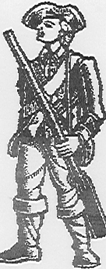
Soldier’s Hardtack

Preheat oven to 450 degrees F.

3 cups flour
1 cup plus 1 tablespoon water

Directions:

Add the water to the flour and mix thoroughly to make a soft (but not sticky) dough. Dust flour on the board to keep dough from sticking. Knead and punch the dough on the board for about 10 minutes. The dough will become elastic, like chewing gum.

Roll the dough out about ½ inch thick and cut in circles with a biscuit cutter or the rim of a drinking glass.

Lay the biscuits on the baking sheet and prick them a couple of times with a fork to keep air bubbles from forming as they bake.

Bake for about 7 minutes. Turn the oven down to 350 degrees F and bake 7 to 10 minutes more. The biscuits should be hard as a rock.

Hardtack never spoiled. Soldiers sometimes ate it years after it was baked.

Do not try to eat these without soaking them first. Try dipping them in a cup of hot broth or warm cocoa.
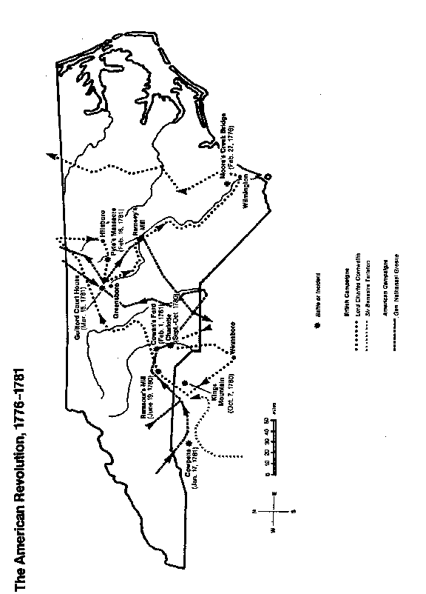

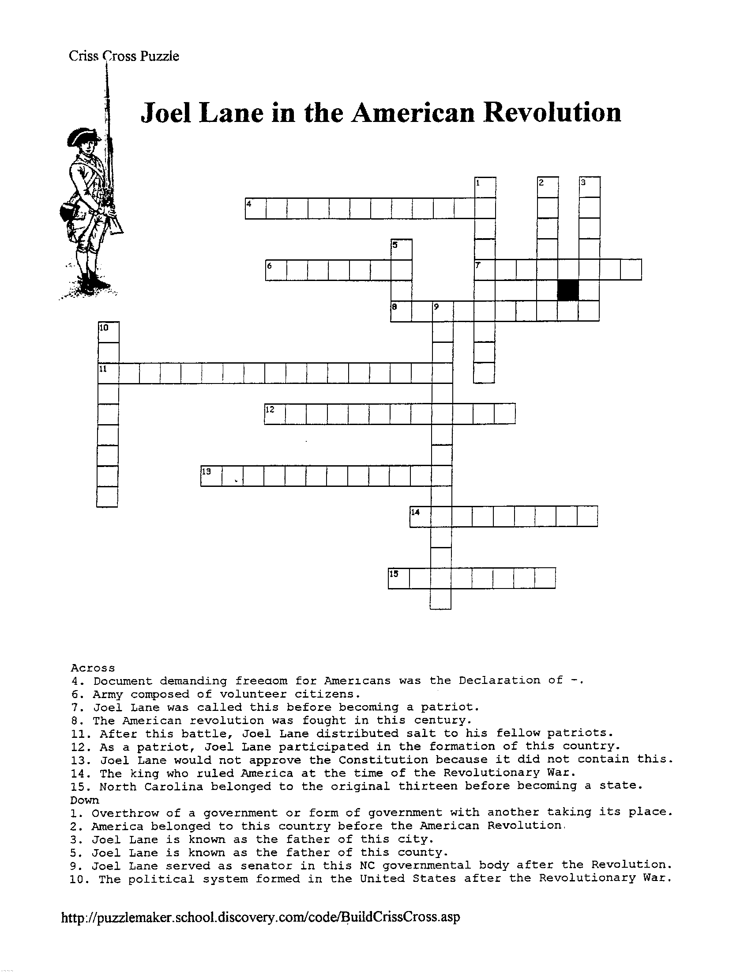
Lesson Four: Traveling in the Colonies
Integrating Mathematics, Language Arts, Technology, Information Skills
Competency Goals: Grade 3
The learner will explain geographic concepts and the relationship between people and geography in real life situations.
The learner will recognize how technology is used at home, school, and in the community.

Competency Goals: Grade 4
The learner will apply the five themes of geography to North Carolina
The learner will trace the history of colonization in North Carolina and evaluate its significance for diverse people’s ideas.
The learner will analyze social and political institutions in North Carolina such as government, education, religion, and family and how they structure society, influence behavior and response to human needs.
The learner will recognize how technology influences change within North Carolina.

Competency Goals: Grade 5
The learner will apply key geographic concepts to the United States and other countries of North America.

FOCUS AND REVIEW:
*Joel Lane moved from Halifax, NC to the area now known as Raleigh to build his home and plantation.
*Remind students that in Joel Lane’s lifetime roads were like paths. Travel was difficult.
*Joel Lane traveled frequently to accomplish his duties as a statesman.

TEACHER INPUT:
*Provide modern maps of the United States, North Carolina divided into counties, and Wake County with cities, towns,
rivers and streams.
*Instruct students in the use of map legends.
*Allow computer time at: www.mapquest.com (scroll to Express Lane and type in (from) Halifax, NC and (to) Raleigh, NC. Click on: get
directions. This will tell you that today a trip from Halifax to Raleigh will take approximately 1 ¾ hours and will be a distance of approximately 80 miles.)
*Ask: What towns have grown up along this route J.L. might have used?
If he went “as the crow flies,” what rivers and streams would he have had to cross?
If Joel Lane used a horse and wagon that traveled about 5 miles an hour, approximately how long would his trip
from Halifax to Raleigh taken him? (Things to consider: traveling only in daylight; horses pulling
wagons tire easily; people would need to stop and eat, etc.) Would he have moved in one day?
Where can you travel in an hour? A day?
What kinds of things make the travel longer or shorter for you? How are the obstacles you encounter in your
travels different from those Joel Lane encountered?

INDEPENDENT PRACTICE:
Students will:
*Use classroom resources to find definitions of legend, compass rose, cartography
*Explain the meaning of legend, compass rose, cartography by writing the definition in a complete sentence.
*Find an outline map of Wake County, North Carolina using:
www.lib.utexas.edu/Libs/PCL/Map_collection/north_carolina.html
*Notice the scale and the north arrow.
*Understand the approximate locations of Halifax and Raleigh.
*Use the legend to figure the approximate distance between Halifax (in Halifax County) and Raleigh (in Wake
County).
*Use Mapquest to confirm calculated information about distance and travel time from Halifax, NC to Raleigh, NC.
*Answer queries about time and distances when traveling, and compare and contrast travel in Joel Lane’s lifetime
to their own.

CLOSURE:
*Students will either write a report relating the difficulties of travel in Joel Lane’s lifetime (or)
*Draw a map of North Carolina showing the major land formations, rivers, streams, and other natural
hindrances Joel Lane would have encountered moving to Raleigh from Halifax (or)
*Make a chart comparing and contrasting travel in the eighteenth century to modern day travel.

MATERIALS:
Maps; Computer; Geography resource materials especially atlases; Boy Scout orienteering handbook, compasses

EXTENSIONS:
- Joel Lane traveled frequently during his lifetime on business of local, state, and national importance. Allow students to choose another city to which Joel Lane traveled and figure time and distance.
- Ask students to think about and be able to discuss Joel Lane’s level of commitment to the cause considering difficulties and obstacles to participation in civic affairs.
- Ask students to decide if they think people were more committed to participation in civic affairs in colonial times, and if so, why; then write their thoughts in two or more paragraphs.
- Ask students to construct a timeline showing Joel Lane’s accomplishments, beginning with Joel Lane’s birth and ending at his death.
- From Maps-on-File at local public libraries, teacher can copy outline map of Wake County and have students identify main town, waterways, etc.
- Compare a historical map to a modern road map of the same area. Make a chart showing similarities and differences.

NOTES:

Lesson Five: Colonial Culture
Integrating Art, Music, Language Arts, Physical Education, Information Skills
Competency Goals: Grade 3
The learner will characterize qualities of good citizenship by identifying people who made a difference in the community and other social
environments.
The learner will analyze the multiple roles that individuals perform in families, workplace and communities.

Competency Goals: Grade 4
The learner will examine the importance of the role of ethnic groups and examine the multiple roles they have played in the development of
North Carolina.
The learner will analyze social and political institutions in North Carolina such as government, education, religion, and family and how they
structure society, influence behavior, and response to human needs.
The learner will examine the impact of various cultural groups on North Carolina.
The learner will recognize how technology influences change within North Carolina.

Competency Goals: Grade 5
The learner will trace key developments in United States history and describe their impact on the land and people of the nation and its
neighboring countries.

FOCUS AND REVIEW:
Colonists’ lives were both the same and different as our lives today.
Colonial North Carolina was populated with Native Americans, and by English, French, German,
Scotch-Irish, and African people and their descendents.
Colonists brought customs and practices from their native lands.
North Carolina is richer and benefited from the cultural mix in the region.

TEACHER INPUT:
*Background information about colonial North Carolina: where people settled, why, etc.
*Access to materials regarding colonial art and music, clothing, holidays, food.
*Access to information regarding adult and children’s roles in colonial America.
*Access to information regarding role of slaves in colonial life.
*Remind students that certain holidays developed along with our country.
*Inform students that some holidays we celebrate today were celebrated in different ways in colonial
times, or not celebrated at all (birthdays, 4th of July, for instance).
*Assign students to collaborative groups for some of the activities.

INDEPENDENT PRACTICE:
Using the internet, library resources, classroom resources, and JL Education Packet,
students will:
- Research an 18th century American artist and his work or an 18th century Connecticut home and compare it to a comparable* of the 20th/21st century. Choosing from following 18th century works:
*Joseph Badger: Portrait of Abigail Gowen
*John Singleton Copley: Mrs. Nathaniel Allen
*(or) Foxon, Ct. room
Above all found at: http://artsmia.org/art_in_america/index.html
*Benjamin West: A Domestic Affliction
found at: http://metalab.unc.edu/wm/paint/auth/west
- Students may use “Think Questions” found at Minneapolis Institute of Arts (artsmia) site to write a comparison essay about the art/artist they chose.
- Using Period clothing handout, draw an 18th century woman or man dressed in North Carolina backcountry outer clothing on one side of a large piece of drawing paper and on the other draw the same gender dressed in contemporary clothing.
- Imagine you live on a farm. How does this way of life differ from your own? How does farm life differ today from colonial times? Chart or write an essay.
- Bring a “made from scratch” recipe from home and decide if it could have been prepared in the 18th century. If so, describe what kind of things an 18th century woman would have to do to prepare such a recipe. (or) Using teacher provided recipe, students will brainstorm what the preparation of such a recipe would entail in the 18th century and who would be involved in the preparation.
- Think about foods they use for celebrations in their own homes and why those foods are used. Have students share with a partner. Students and teacher will share with the rest of the class. Discussion will ensue around similarities and differences.
- Using what they have learned about the nationality and ethnicity of the different people who settled North Carolina, students will prepare a list of contributions of each to the culture of North Carolina.
- Identify his/her own ethnicity and prepare a list of contributions from his/her family background to the culture of N.C.
- Use a computer (or teacher will print copies) to locate “The Exercise of a Schoolboy” by George Washington. Students will prepare a chart comparing colonial school manners with today’s school manners.
- Print out or read online “About Colonial Music” at:
http://users.aol.com/Davenging/dgabtcm.htm
- Listen to music of the period.
- Learn the Virginia Reel.
- Use the internet site: http://history.org/life/xmas/xmasqa.htm to read” “Another Look at Christmas in the Eighteenth Century” by David DeSimone. Students will compare a December holiday from their culture with that of southern colonists in Virginia. (Roles of women, children, and slaves can also be examined here.) *Students may also read the story sheet entitled “Christmas at Wakefield” which is available on parchment from the J.L. Museum House. Compare J.L. Christmas with that of other eighteenth century colonials.
- Using primary sources provided, complete “Christmas: Then & Now Graphic Organizer” in collaborative groups from:
http://www.history.org/other/teaching/thennow.htm
- Decide whether you prefer to live the way we live today or the way colonists lived and write a paper of several paragraphs defending your choice. (Consider school, medicine, playmates, safety issues, ease of travel, clothing styles, food, etc.)

CLOSURE:
Decide on a season, decorate the classroom in a style a colonist would recognize, prepare colonial festive foods, and celebrate North Carolina colonial culture. Ask students to dramatize people from Joel Lane’s life and keep in character at the festivity.

MATERIALS:
Resource materials from school and public library; Colonial Clothing handout; Virginia Reel directions handout; Computer access and computer sites previously listed; Music: Colonial Social Dancing for Children (see resources); Drawing paper

*The Minneapolis Institute of Arts site will have 20th and 21st century works with which to compare the students’18th century choice. Use the same site or:
- Field trip to NC Museum of Art in Raleigh. Use the opportunity to appreciate their collection of 18th century American works. Find 20th and 21st century works to compare and contrast.
- Explore the other museums online. Two very good sites are:
Art History on the Web: http://witcombe.sbc.edu/ARTLinks.html click on your choice
Art – Museums: http://www.kidsvista.com/ARTS/art.html lots of links

VIRGINIA REEL
(adapted from November 1997 NTA Newsletter, as found at
http://www.apci.net/~drdeyne/dances/vareel.htm

This dance was first published in England in 1685. It has been enjoyed since colonial times in America and around the world.

FORMATION: Two lines of partners. Partners stand facing each other with 5-7 feet between the lines. The lines have a head and a foot, with the head couple being the nearest to the band or music source, and the foot couple at the other end of the line. This dance is best when there are not more than six partners in each set.

STEP: The step is a light walk on the toes or balls of the feet.

CALLS: The following numbered calls are given by the leader for beginners, or where there are several sets, in order that all may keep together.

MUSIC: Choose lively old time reel music such as “Durang’s Hornpipe” or “Old Zip Coon” or you may wish to use newer music such as a selection from the Atlantic Pops album, Hooked on Country.

PART I – THE TURN
- Head lady and foot gentleman forward and back. (Honor your partner.) The head lady and the foot man advance diagonally toward each other four steps, curtsey and bow, and retire four steps backward into place. The head man and foot lady do likewise immediately.
- Forward and turn with the right hand round. The head lady and the foot man advance, join left hands (shoulder high), make one complete turn and return to places. The head man and foot lady do the same.
- Forward again with the left hand round. The head lady and foot man advance, join both hands straight across and make one complete turn, then return to places. The head man and foot lady do the same.
- Do-Si-Do (pronounced dough-see-dough) The head lady and foot man advance, pass each other right shoulder to right shoulder, and without turning, go around each other back to back and retire backwards to places. The head man and foot lady do the same. Repeat the Do-si-do by left shoulder.
- Head couple down the center and back. The head partners join both hands and chasse (side slip and close) down inside of the lines four steps and return to head position.

PART II – THE REEL

6. Right arm to partner and reel. (Right to center, left to the side.) The head partners link arms and
turn one and a half around. (This leaves the lady backing the men’s line and the man facing the ladies’ line.)
The head lady turns the second man in line around in his place with left arms linked, while the head man does
likewise with the second lady in line. Head partners then return to the middle and turn to each other again
with right arms linked. To teach the reel, it is sometimes helpful for the leader to call, “Right to the center,
left to the side.” This is continued, each swinging the next in line until they reach the foot of the lines, where
they swing each other half-way around with right arms linked, so that the lady finishes on her own side and the
man on the men’s side. The head partners then join hands across and chasse (side slip and close) with side
steps back to the head position of the set. They drop hands and turn out ready for the march.

Virginia Reel – Page 2
PART III – THE MARCH

7. The head partners separate. The man turning out and marching toward the foot directly behind the
men’s line, following by the men in single file, and the head lady at the same time marching down the outside of
the lady’s line followed by all the ladies in single file. Then, the head partners meet at the head of the set,
followed by the other partners. When all have reached their original places, all the partners, except the head
partners, join hands and hold them high to form a long archway under which the head partner, with hands
joined, side step quickly to the foot, where they remain. The original second partners now become head
partners and the whole pattern is repeated until all have been head partners.

VARIATIONS:
When the head partners reach the foot of the set, they stop, join both hands to form an arch while the partners who are behinds then join hands and go under the arch and up the center toward the head position. This leaves the original head partners at the foot and the second partners now become the head partners.

NOTES:

Period Clothing
Eighteenth Century

Women’s Clothing

UNDERWEAR or BODY LINEN
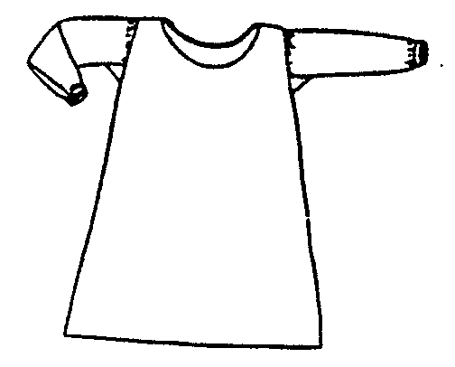

Shift or Chemise
This garment was made of linen and was worn by all classes. The style was ¾ length sleeves (probably with cuffs), round neck, and knee to mid-calf length.

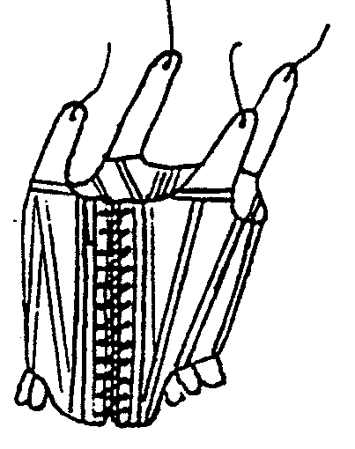

Stays
Stays were always worn with fancy gowns. They were originally made of two layers of fabric with whalebone pieces in between. The lining was linen; the outer, natural linen or colored damask or brocade silk or linen. Stays were always worn over the shift.

Pockets
These are flat cloth bags tied around the waist with woven linen tapes. Pockets were not sewn into women’s clothes. They were made of linen and sometimes cotton. One pocket may be worn or one on each side. Pockets could be plain, embroidered, or pieced. Pockets were almost always worn under the petticoat.
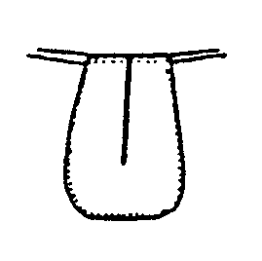

OUTERWEAR
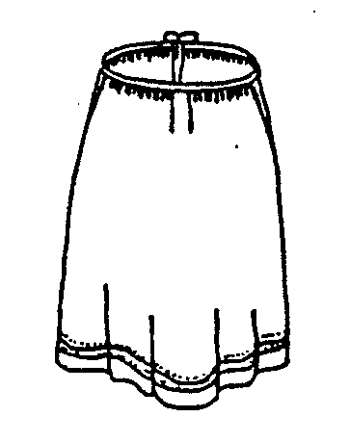

Petticoats
The petticoat was a skirt, usually pleated and long. The top had a tape for a waistband. It tied on the side or in the back. A petticoat could be worn on the outside or as an under-petticoat under another, especially in winter. It had a narrow hem and often had one or more tucks near the hem. Petticoats would be made of either wool or linen.

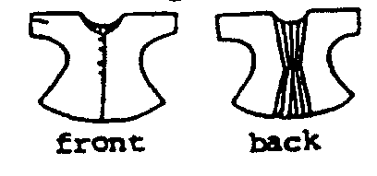
Shortgown
BODICEWEAR

Lower class wear in America did not usually include long gowns. The shortgown is a separate garment, not just a cut-off gown. It had no seam on the shoulder or around the armhole. One long seam ran underneath the sleeve and down the side. It is not a form fitting garment. They were usually lapped and pinned in front with straight pins or thorns.

A bedgown is similar to a shortgown but longer in body length and sleeves and has a small straight collar.

A jacket is more fitted. It has set-in sleeves, fitted seams and usually more detailed trim. It can be many lengths to below hip level. It often has light boning. Jackets were generally fastened with pins or hooks and eyes. They were fitted to be worn over stays.

Any of these garments would be made of linen, wool, or cotton.

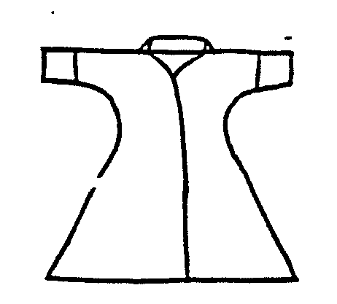
Bedgown

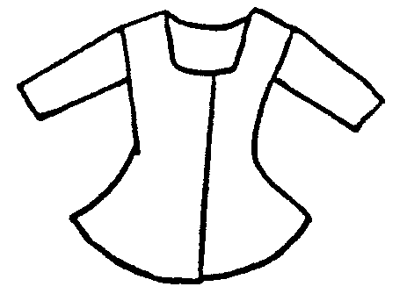
Jacket

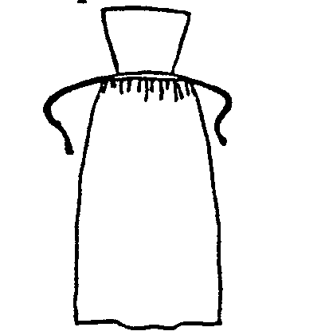
APRONS

An apron was a piece of linen gathered to a very narrow band and tied with linen tapes. Some aprons had pinners, a bib-like top. The pinner was pinned with straight pins or thorns. Aprons were always worn with everyday clothes.

NECKERCHIEF

A square piece of linen folded into a triangle and worn around the neck was also called a handkerchief. It was either tucked into the shortgown or jacket or worn outside and pinned in front. Neckerchiefs were made of white, checked, or plaid linen.
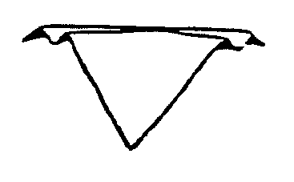

CAPS

A wide variety of caps was worn. All were white linen. A woman’s hair was always tucked up inside of her cap.

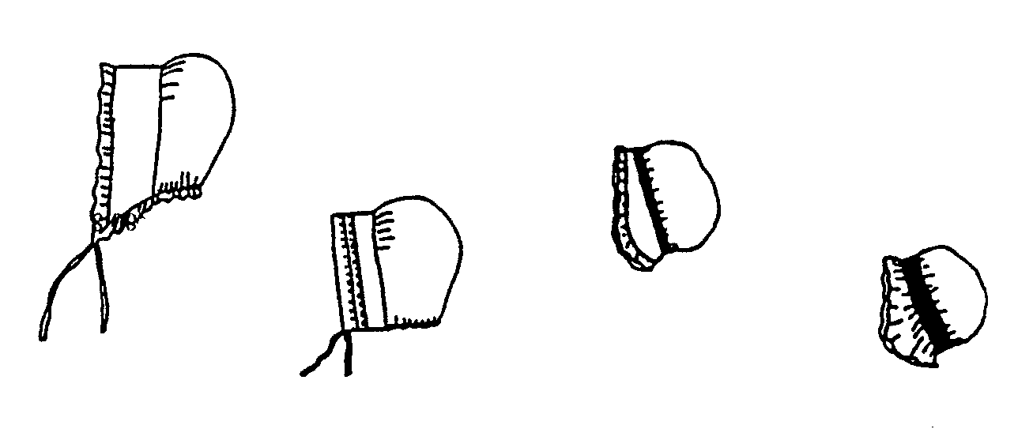
Men’s Wear

UNDERWEAR

Shirt

This garment was made of linen and was worn by all classes. The shirt was very long, usually to mid-thigh, with a single button at the neck and a button on each cuff. A work shirt was made of coarse linen, with small bone buttons. A dress shirt, of the same style, was made of fine, bleached linen, with delicate cloth buttons, ruffles at the throat and cuff, and an embroidered monogram on the front. The most common color of shirts was white, but many everyday shirts were dyed with natural dyes, perhaps to cover stains.
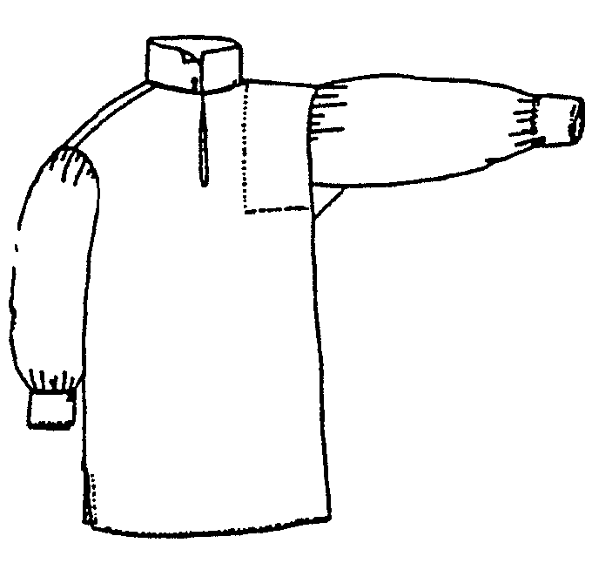

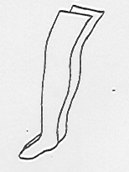

Stockings

Stockings were knitted of linen thread or wool and came up over the knee. Stockings were usually dyed brown or blue or left the natural tan. There were pulled up over the knee and tied with linen tape garters. These were worn by both men and women.

OUTERWEAR

Breeches

Knee-length breeches were the most common style worn in colonial America. Breeches were sometimes made of leather, especially in rural areas. Cloth breeches were made of linen or wool. Most breeches were made with a gusset in back of the waistband which made the breeches adjustable for several waist sizes. They were full in the seat, allowing freedom of movement and comfort. The square panel on the front of the breeches was called a fall.

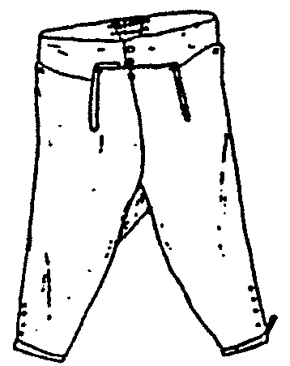

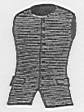

Waistcoat

A waistcoat looks similar to what we would call a vest. Waistcoats were made of linen or wool and were usually lined with linen. During hot summer months, unlined waistcoats of very light linen were worn by the wealthier classes. They were always worn as part of a formal suit.

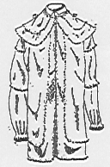

Frock Coat

The frock coat evolved from the long formal coats of the early eighteenth century. It had a turned down dollar and a looser fit than a dress coat. They could be almost formal looking out of fine linen or wool with a lining. The hunting frock seen often in the backcountry was made of linen, with a large cape around the collar.

Stock

Stocks were worn around the neck, under or over the shirt collar, depending on the type of stock used. Stocks were made of leather or linen. A backcountry farmer would probably have tied a handkerchief around his neck instead of a stiff stock.
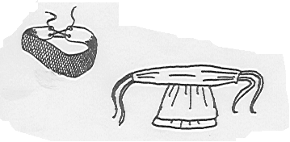

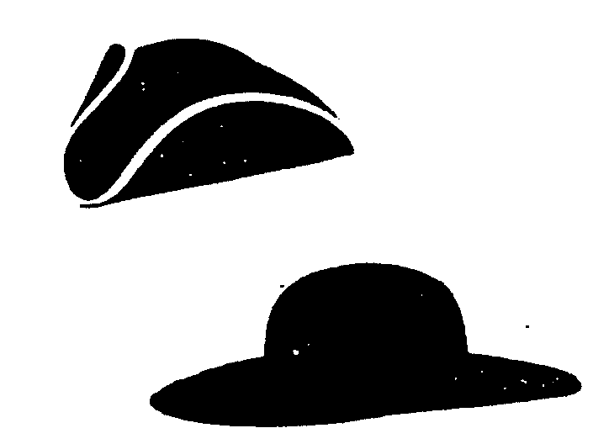

Hats

A hat with its brim cocked up on three sides was the most common style for fashionable wear. Uncocked hats were also worn, especially by men in the backcountry. Straw hats were worn as well as soft caps of woven or knitted fabrics while working at home or in the fields.

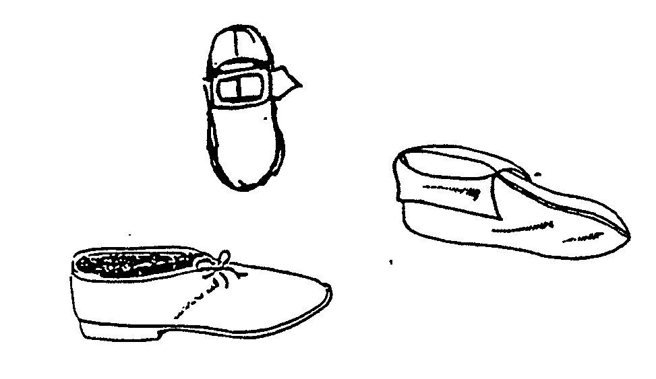

Shoes

Ordinary shoes for men and women were made of leather with either buckles or ties made of leather or fabric. Women had dressier shoes made of fabrics to match their formal gowns. In the backcountry both men and women could also wear Eastern style Indian moccasins.

CHILDREN’S CLOTHES

Young boys and girls were dressed in shifts, petticoats, shortgowns, and caps. Boys wore petticoats until age five or six when they would be dressed in shirts and breeches or trousers. The clothing for boys and girls after age six was patterned after those of their parents.

Excerpts taken from:

Eighteenth-Century Clothing at Williamsburg by Linda Baumgarten.

“Eighteenth Century Women’s Clothing Regulations” from the North Carolina Historical Re-enactment Society

RESOURCES

Cross, Jerry, Chameleon on the Crabtree: The Story of Joel Lane

Mathews, Alice Elaine, Society in Revolutionary North Carolina (Raleigh: North Carolina Department of Cultural Resources,
Division of Archives and History, 1976).

Murray, Elizabeth Reid, Wake: Capital County of North Carolina (Raleigh: Capital Publishing Company, 1983).

Powell, William S., North Carolina: Through Four Centuries (Chapel Hill: The University of North Carolina Press, 1989).

Taylor, Dale, The Writer’s Guide to Everyday Life in Colonial America (Cincinnati, Ohio: Writer’s Digest Books, 1997).

Watson, Alan D., Society in Colonial North Carolina (Raleigh: North Carolina Department of Cultural Resources, Division of Archives
and History, 1975).

Watson, Harry L., An Independent People: The Way We Lived in North Carolina, 1770-1820 (Chapel Hill: The University of North
Carolina Press, 1983).

LESSON ONE: THE HOUSE
*Archaeology internet site: http://www.usd.edu/anth/midarch/arch.htm
This site is directed at middle school, but is excellent for interested, mature students.
*Archaeology for Kids: http://www.history.org/cwf/argy/argykids.htm
This site is an activity page for lower level students with activities and games. Good learning or review resource.
*N.C. Archaeology; state page, archaeology related links: http://www.arch.dcr.state.nc.us/links.htm Scroll down. Lots there for
teachers and students.
*North Carolina Museum of History: 5 East Edenton Street, Raleigh, N.C.
*Winters, Nathan B., Architecture is Elementary: Visual Thinking Through Architectural Concepts (Salt Lake City: Gibbs Smith, 1997).
This book is an art resource, but integrates many other disciplines. Very useful for teachers.

LESSON TWO: THE GARDEN
*Internet sites listed in lesson plan
*“A Modern Herbal” by Mrs. M. Grieve online: http://www.botanical.com/botanical/mgmh/mgmh.html
*Colonial Dames of America, Herbs and Herb Lore of Colonial America (New York: Dover Publications, Inc., 1995).
*Colonial Williamsburg publications, especially: “Every Man His Own Doctor: or, The Poor Planter’s Physician” from Colonial
Williamsburg Foundation (757) 220-7536.
*The Colonial Williamsburg site:
A Williamsburg Perspective on Colonial Gardens: http://www.history.org/life/garden/garinto.htm
Gardens Bibliography: http://www.history.org/life/garden/gardnbib.htm
*Hooper, Madge, A Superguide to Herbs and Medicinal Plants (New York City: Gallery Books for Kingfisher Books, 1989).
*Leighton, Ann, Early American Gardens: For Meate or Medicine (Boston, MA: Houghton Mifflin Company, 1970).
*North Carolina Museum of History, 5 East Edenton Street, Raleigh, NC: North Carolina Medicines Exhibit.

LESSON THREE: JOEL LANE in the AMERICAN REVOLUTION
*Archiving Early America: historic documents from 18th century America: http://earlyamerica.com Click on “Enter the World
of Early America”
Copies of documents as they appeared in the media of the day. Available are the Declaration of Independence, The
Constitution, and the Bill of Rights. Other items of interest to the student of colonial America.
*A Virtual Museum of the Revolutionary War: http://home.ptd.net/~revwar/museum.html Has primary documents
*Division of Archives and History, Historical Publications Section, 109 Jones Street, Raleigh, NC 27601-2807
Offers a free catalog listing publications relating to North Carolina History
*Division of Archives and History, Historical Publications Section, 109 Jones Street, Raleigh, NC 27601-2807
Offers a free catalog listing publications relating to North Carolina History
*Facts on File Maps
*Famous Afro-Americans in the American Revolutionary War: http://www.ilt.columbia.e.du/k12/history/aha/blacks.html
Click on name, document, incident
*Internet Sites listed in lesson plan
*Library of Congress/American Memory/Learning Page: http://learning.loc.gov Click Enter, then: Learning Page, then: Learn
more, then: Educators and Historians, then: Scroll to “Continental Congress and the Constitutional Convention 1774-1789”
This site has good background information and many primary and secondary sources.

Resources – Page 2
*National Constitution Center, teacher resources:
http://www.constitutioncenter.org/sections/teacher/lesson_plans/html/00650a.asp
Useful Bibliography included at “Eighteenth Century Constitutional Party”
*National Archives and Records Administration, Images of the American Revolution: http://www.nara.gov
Click on: Digital Classroom, then: The Constitutional Community, then: Images of the American Revolution.
This site has primary source documents, engravings, and an excellent Historical Background on the American Revolution.
*North Carolina Museum of History, 5 East Edenton Street, Raleigh, NC
Exhibits, audiovisual materials for loan or purchase, Tar Heel Junior Historian magazine (especially “Battle of Moores Creek
Bridge” by Julia Ribet, February 1964, pages 9-10), Museum Shop
*Puzzles (make your own) and games useful for the classroom at: http://puzzlemaker.school.discovery.com/index.html
*State Library of North Carolina: http://statelibrary.dcr.state.nc.us Scroll down to “Information Resources from the State
Library,” then: Click on NC Encyclopedia and Scroll down to History, then: Click on Historic Sites, then: List of NC
historic sites, then: Moore’s Creek Bridge
This site is a wealth of information about North Carolina.
*UNC-TV Production on the Battle of Alamance
For information: UNC Center for Public Television, PO Box 14900, RTP. 919 549-7000.

LESSON FOUR: TRAVELING in the COLONIES
*Boy Scouts of American, Merit Badge Series: Orienteering
*Facts on File, available in most libraries
*Internet sites listed in the lesson plan
*Maps on File, available in most libraries

LESSON FIVE: COLONIAL CULTURE
THE JOEL LANE MUSEUM HOUSE, Corner St. Mary’s and Hargett Streets, PO Box 10884, Raleigh, NC 27605.
(919) 833-3431
BURGWIN WRIGHT HOUSE, 224 Market Street, Wilmington, NC 28401. (910) 762-0570
DIVISION OF ARCHIVES AND HISTORY, address and phone in previous section
HAYWOOD HALL, The Friends of Haywood Hall, 211 New Bern Place, Raleigh, NC 27601. (919) 832-8357
HISTORIC BATH, PO Box 148, Bath, NC 27808
HISTORIC HALIFAX, PO Box 406, Halifax, NC 27839 (191) 583-7191
HOUSE IN THE HORSESHOE, Rte.3, Box 924, Sanford, NC 27330
MORDECAI HISTORIC PARK, Capital Area Preservation, One Mimosa Street, Raleigh, NC 27604. (919) 834-4844
NC MUSEUM OF HISTORY, address and phone in previous section
NC STATE HISTORIC PRESERVATION OFFICE, 4617 Mail Service Center, Raleigh, NC 27699-4618. (919) 733-4763
OLD SALEM, Old Salem, Inc., Box F, Winston-Salem, NC 27108
RALEIGH CITY MUSEUM, Briggs Building, Suite 100, 220 Fayetteville Street Mall, Raleigh, NC 27601-1310. (919) 832-3775
TRYON PALACE HISTORIC SITES AND GARDENS, PO Box 1007, New Bern, NC 28563
WAKE COUNTY HISTORICAL SOCIETY, PO Box 2, Raleigh, NC 27602. (919) 782-0560
*Academic Info U.S. History: Early America http://www.academicinfo.net/usearly.html
Invaluable resource. Links to special areas
*Books such as:
Baumgarten, Linda, Eighteenth-Century Clothing at Williamsburg, part of Williamsburg Decorative Arts
Series (Williamsburg, Virginia: The Colonial Williamsburg Foundation, 1988).
Cohen, Hennig and Tristram Potter Coffin, eds., The Folklore of American Holidays (Detroit, Michigan: Gale
Research Company/Book Tower, 1987).
Crump, Nancy Carter, Hearthside Cooking (McLean, Virginia: EPM Publications, 1986).
*Catalogs:
Buffalo Enterprises/Everything for Period Living Jas. Townsend and Son, Inc. online
Buffalo Enterprises of Pennsylvania http://www.jastown.com
308 W. King Street click on pictures of 18th century clothing, music,
Box 183 eating equipment, games, etc.
East Berlin, Pennsylvania 17316
Drawings of clothing and other goods. (Small charge for catalog)
*Colonial Williamsburg site: www.history.org
*Haywood, Maggie, Christmas at Wakefield/ A Historical Story. Pamphlet. Joel Lane House, Inc.
*Internet sites listed in the lesson plan
*Music from: Colonial Social Dancing for Children (book) (or) Music for the Dances in Colonial Social Dancing (2 tape set)
The Hendrickson Group, PO Box 766, Sandy Hook, CT 06482-0766. (203) 426-9266. dance18thc@aol.com
(and) Colonial Life in America by Louis Sabin (1 cassette), Troll Associates, Maahwah, NJ.

Resources – Page 3
Music, continued:
Colonial Singing, Games, and Dances: Colonial Williamsburg Foundation
*Old Salem publications describing colonial life for children. Old Salem, Inc., Box F, Winston-Salem, NC 27108
*Replitiques: http://www.replitiques.com/history.htm#kitchen
Commercial site, but…Scroll down for history and bibliography. Be sure to get to the bottom of the page. Lots there.
*“Specials” teachers in your school

RESOURCES FOR STUDENTS

Barrett, Tracy, Growing Up In Colonial America (Connecticut: The Millbrook Press, Inc., 1995).

Carlson, Laurie, Colonial Kids (Chicago, IL: Chicago Review Press, Inc., 1997).

Carson, Mary Kay, Colonial America (New York: Scholastic Professional Books, 1999).

Copeland, Peter F., Everyday Dress of the American Colonial Period, Coloring Book (New York: Dover Publications, Inc., 1975).

Corbishley, Mike, The World of Architectural Wonders (New York: Peter Bedrick Books, 1996).

Corwin, Judith Hoffman, Colonial American Crafts: The School (New York: Franklin Watts, 1989).

______, Colonial American Crafts: The Village (New York: Franklin Watts, 1989).

______, Colonial American Crafts: The Home (New York: Franklin Watts, 1989).

Coxe, Vivian Barbee, Eliza and The Edenton Tea Party (Raleigh: Martini Print Media, Inc., 1997).

Dalgliesh, Alice, The Courage of Sarah Noble (New York: Simon and Schuster, 1991).

Dorros, Arthur, This is My House (New York: Scholastic Inc., 1992)
Houses from all over the world. In thirteen languages plus English, with pronunciation. Colorful. Multicultural.

Editors, World Book, Inc., Christmas in Colonial and Early America, (Chicago, IL: World Book Encyclopedia, Inc., 1966).

Erdosh, George, Food and Recipes of the Thirteen Colonies (New York: The Rosen Publishing Group, Inc., 1997).

Erikson, Paul, Daily Life on a Southern Plantation 1853 (New York: Puffin Books, 1998), 10-11.
*Keep in mind that the details of this book take place more than half a century after Joel Lane died. However, the
pages illustrating an aerial view of a plantation might give students a helpful mental picture.

Evert, Jodi, ed., American Girls Collection/ Felicity’s Craft Book (Middleton, WI: Pleasant Company Publications, 1994).

Field, Rachel, Calico Bush (New York: Aladdin Paperbacks, 1999).

Fisher, Leonard Everett, Colonial Craftsmen: The Schoolmasters (New York: Benchmark Books/ Marshall Cavendish
Corporation, 1997).

_____, Colonial Craftsmen: The Cabinetmakers (New York: Benchmark Books/ Marshall Cavendish Corporation, 1997).

_____, Colonial Craftsmen: The Glassmakers (New York: Benchmark Books/ Marshall Cavendish Corporation, 1997).
(also in this series, not reviewed: Colonial Craftsmen: The Doctors)

Freeman, Lucy, America’s First Woman Warrior: The Courage of Deborah Sampson (New York: Paragon House, 1992).

Fritz, Jean, Shh! We’re Writing the Constitution (New York: G. P. Putnam’s Sons, 1987).

_____, Early Thunder (New York: Viking Press, 1987).

Resources for Students – Page 2

_____, George Washington’s Mother (New York: Price Stern Sloan, 1992).

_____, What’s the Big Idea, Ben Franklin? (New York: Coward, 1976).

_____, Can’t You Make Them Behave, King George? (New York: Putnam, 1989).

Gibbons, Gail, How a House is Built (New York: Holiday House, 1990).

Hakim, Joy, A History of US: Making Thirteen Colonies (New York: Oxford University Press, 1993).
(also in this series, not reviewed: The First Americans; From Colonies to Country; The New Nation; Liberty for All?;
War, Terrible War; Reconstruction and Reform; An Age of Extremes; War, Peace, and All That Jazz; All the People)

Howarth, Sarah, Colonial Places (Brookfield, Connecticut: The Millbrook Press, 1994).

James, Alan, Homes in Cold Places (Minneapolis: Lerner Publications Company, 1989).

_____, Homes in Hot Places (Minneapolis: Lerner Publications Company, 1989).

Kalman, Bobbie, The Early Settler Life Series: The Early Family Home (New York: Crabtree Publishing Company, 1992).
(also in this series, not reviewed: Early Christmas; Early Stores and Markets; Early Loggers and the Sawmill; Early
Travel; Early Village Life; Food for the Settler; Early Schools; Early Settler Children; Early Settler Storybook; Early
Pleasures and Pastimes; Early Farm Life; Early City Life; Early Health and Medicine; Early Artisans)

_____, Historic Communities: Colonial Crafts (New York: Crabtree Publishing Company, 1992).

_____, Historic Communities: Colonial Life (New York: Crabtree Publishing Company, 1992).

_____, Historic Communities: Home Crafts (New York: Crabtree Publishing Company, 1993).

King, David C., American Kids in History: Colonial Days (New York: John Wiley & Sons, Inc., 1998).
(also in this series, not reviewed: Pioneer Days; Wild West Days)

Liddiard, Nicola, ed., The Visual Dictionary of Buildings (New York: Dorling Kindersley, Inc., 1992).
Good picture resource. Architectural style time line. Excellent breakdown of building elements vocabulary.

McGovern, Ann, If You Lived in Colonial Times (New York: Scholastic, Inc., 1992).

Moore, Kay, If You Lived at the Time of the American Revolution (NewYork: Scholastic1997).

Murphy, Jim, A Young Patriot (New York: Calrion Books, 1996).

O’Dell, Scott, Sarah Bishop (New York: Houghton Mifflin Co., 1980).

Perl, Lila, Slumps, Grunts, and Snickerdoodles: What Colonial America Ate and Why (New York: Clarion, 1975).

Schleifer, Jay, Our Declaration of Independence (CT: The Millbrook Press, 1992).

Seltzer, Isdore, The House I Live In/At Home in America (New York: Macmillan Publishing Company, 1992). Multicultural.

Warner, John F., Colonial American: Home Life (NewYork: Franklin Watts, 1993).
(also in this series, not reviewed: Colonial American Craftspeople by Bernardine S. Stephens; Colonial American
Holidays and Entertainment by Karen Helene Lizon; Colonial American Medicine by Susan Neiburg Terkel)

